PRIMARY FIVE SOCIAL STUDIES LESSON NOTES

THEME: LIVING TOGETHER IN OUR DISTRICT.

**TABLE OF CONTENTS**

TERM ONE .

Topic 1: Location of our district in Uganda.

Maps and pictures

Elements of a map

How to locate places

Locating places using lines of longitude and lines of latitude

Location of our district in Uganda

Regions that form Uganda

Kampala district

The history of our district

Important places in our district

Topic 2: Physical Features of Uganda.

Introduction to Physical Features

Mountains and Hills in our district

Valleys and the Rift Valley

Plateaus and plains

Lakes in our district

Rivers in Uganda

General importance of Physical Features

TOPIC 1:

LOCATION OF OUR DISTRICT IN UGANDA.

## MAPS AND PICTURES.

 **A map** is a drawing/ representation of an object as seen from above.  Maps show how objects look like when viewed directly from above.

 We use symbols to help us understand and interpret a map of a detailed area.  The boundary of a map determines the size and shape of the map.

 **A picture** is a representation of an object drawn as seen from aside.  All features on a picture can be clearly seen as real objects.

 Pictures are more detailed than maps.

### Maps and Pictures of different objects

|  |  |  |
| --- | --- | --- |
| ***Object name*** | ***Picture*** | ***Map*** |
| a tree |  |  |
| a plate |  |  |
| a pot |  |  |
| a house |  |  |
| a chair |  |  |
| a cup |  |  |
| a hut |  |  |

|  |  |  |
| --- | --- | --- |
| a car |  |  |
| a table |  |  |

Similarity between maps and pictures.



* Both are representations of objects. Difference between a picture and a map.
* A picture is drawn as seen from aside while a map is drawn as seen from above.
* A picture is more detailed than a map.

***Testing Exercise.***

* 1. Give the meaning of each of the following;
     1. A picture
     2. A map
  2. Give one way a map is similar to a picture.
  3. Why is it easier for one to understand a picture of an object than its map?
  4. How is a map different from a picture?
  5. Draw the maps of the following objects.

|  |  |  |  |
| --- | --- | --- | --- |
| *a cup* | *a circular table* | *a pot* | *a tree* |
|  |  |  |  |

## ELEMENTS OF A MAP.

* A key
* A scale
* A heading/ title

### Importance of different elements of a map.

* A compass direction
* A frame.

|  |  |
| --- | --- |
| ***Element*** | ***Importance*** |
| * A compass direction | * It helps to show the direction of places on a map |
| * A title/ heading | * It helps one to know what the map is all about. |
| * A key | * It helps a map reader to interpret symbols used on a   map. |
| * A scale | * It helps a map reader to calculate the actual ground   distance on a map. |
| * A frame | * It shows the extent of the area represented by the   map. |

**Problems a map reader may face when reading a map without the map elements.**

|  |  |
| --- | --- |
| ***Element missing*** | ***Challenge a map reader is likely to face*** |
| * *Without a* ***compass direction*** | * Failure to know the direction of places on a map |
| * *Without a* ***title/***   ***heading*** | * Failure to know what the map is all about. |
| * *Without a* ***key*** | * Failure to interpret symbols used on a map. |
| * *Without a* ***scale*** | * Failure to calculate the actual ground distance on a map. |
| * *Without a* ***frame*** | * Failure to know the extent of the area represented by   the map. |

## MAP SYMBOLS.

 These are features that are used to represent real objects on a map. Why symbols are used on maps.

* + To avoid congestion on the map.
  + To make map reading easy.
  + To ensure neatness of the map.

**Common symbols used on maps.**

|  |  |  |  |  |  |
| --- | --- | --- | --- | --- | --- |
|  |  |  |  |  |  |
| *A rift valley* | *waterfall* | *A dam* | *A canal* | *A swamp* |
|  |  |  |  |  |  |
|  | *A quarry* | *A hill* | *airport* | *contours* | *a factory* |
|  |  |  |  |  |  |
|  | *Railway line* | *A port* | *hospital* | *mountain peak* | *permanent lake* |
|  |  |  |  |  |  |
|  | *Seasonal lake* | *church* | *A bridge* | *Seasonal river* | *Compass direction* |
|  |  |  |  |  |

## A SCALE.

 A scale helps a map reader to calculate the actual ground distance on a map.

 A map reader who reads a map without a scale may fail to calculate the actual ground distance on a map.

 A scale is only found on accurate maps.

 A sketch map is a map which is not drawn to scale while an accurate map is a map which is drawn to scale.

Types of scales.

1. **Linear scale.**

This is the type of scale drawn using lines that are divided into equal parts.



1. **Rational/ fractional scale.**

This is the type of scale written as a mathematical fraction.

It can also be written as a ratio.eg. 1

100km

or 1:100km.

1. **Statement scale.**

This type of scale can be given as a statement or words. Eg.1cm on a map represents 100km on the ground.

## MEASURING AND CALCULATING DISTANCE OF PLACES USING A SCALE

#### Example 1.

Find the actual ground distance between town Q and town S if there is a distance of 6cm between the two towns on the map using the scale below.



Solution;

1cm = 100km 6cm = (6×100)km

= 600km.

Therefore, the actual ground distance between Town Q and Town S is 600km.

#### Example 2.

Calculate the actual ground distance from town A to town B on the diagram below.

**A** 5cm **B** using a scale 1cm represents 10km Solution;

1cm = 10km 5cm = (5×10)km

= 50km.

Therefore,the actual ground distance between Town A and Town B is 50km.

#### Example 3.

Find the actual ground distance between Kampala and Jinja if there is a distance of 8cm between the two towns on the map.( use the scale 1cm=10km)

Solution;

1cm = 10km 8cm = (8×10)km

= 80km.

Therefore,the actual ground distance between Kampala and Jinja is 80km.



***Testing Exercise.***

* 1. Mention any four elements of a map.
  2. State the importance of each of the above elements to a map reader.
  3. Draw the map symbols of each of the following features.

|  |  |  |  |
| --- | --- | --- | --- |
| *a railway line* | *a swamp* | *a bridge* | *a mountain peak* |
|  |  |  |  |

* 1. Which problem is a map reader likely to face when reading a map without a key?
  2. Give any two reasons why symbols are always used on maps instead of real objects.
  3. Mention the two types of scales used on maps.
  4. Why are maps drawn by P.4 pupils referred to as sketch maps?
  5. Mention the three types of map scales.
  6. Calculate the actual ground distance between town W and town Y if there is a distance of 8cm between the two towns on the map.

(using the scale 1cm=10km)

* 1. Name the type of scale is shown below.

**15 30km**

## HOW TO LOCATE PLACES.

 Location is the place where something is found.

 **Location** refers to the position of something or a place. Ways of telling direction of places.

* + - By using the position of the sun.
    - By using the compass. Ways of locating places.
* By using maps.
* By using land marks eg. hills, mountains
* By using neighbourhood/ neighbouring places.
* By using a compass.

Ways of locating places on a map.

* + By using the grid reference system/ lines of latitude and lines of longitude.
  + By using a compass direction.
  + By using the neighbourhood.
  + Using landmarks.

## USING A COMPASS.

 **A compass** is an instrument used to show direction of places.

 **A compass direction** is the symbol used to show direction of places on a map.  A compass needle always points to the **North** when a compass is at rest.

 The determinant point of a compass is **North. ** **A compass rose** is a drawn compass.

### Cardinal points of a compass.

 Cardinal points are the four major points of a compass.  Cardinal points of a compass include;

* North
* South
* East
* West

**A diagram showing cardinal points of a compass.**

**North**

**West East**

**South**

### Semi- cardinal points of a compass.

 These are points that lie between/ midway the cardinal points.  They lie at 450 from the cardinal points.

 These points are also called the **semi-cardinal** or **ordinal points**.  Secondary points of a compass include;

* North East
* South East
* North West
* South West

**A diagram showing the Semi-cardinal points of a compass.**

**North**

**West**

**East**

**South**

**South East**

**South West**

**North East**

**North West**

Groups of people who use a compass.

* Rally drivers
* Tourists
* Pilots
* Mountain climbers
* Sailors
* Scouts and girl guides.
* Soldiers

## DEGREES AROUND THE COMPASS

 The face of a compass is circular and is equivalent to 3600  Cardinal points form at 900 from each other.

 Semi cardinal points form at 450 between two nearby cardinal points.

 The starting point is always at North with 00 and the ending point is also at North with 3600.

 Starting from the North moving clockwise,

* + North lies at 000 or 3600
  + East lies at 900
  + South lies at 1800.
  + West lies at 2700



(1800)

**South**

**South East**

**South West**

**450**

**450**

**East** (900)

***Clockwise movement***

**450**

**450**

**450**

**450**

**450**

**450**

***Anti-clockwise***

(2700) **West *movement***

**North East**

**North West**

**North** (000 or 3600**)**

#### Example 1.

Okello was facing North East and he turned through an angle of 1350 clockwise. Which new direction did he face?

**Solution:**

**North**



**North West**

**North East**

**West**

**450**

**450**

**450**

**East**

**South West**

**South East**

**South**

Okello’s new direction was South.

#### Example 2.

Which new direction does Jemimah face if she turns from the South East 900 anti- clockwise ?

**Solution:**

**North**



**North West**

**North East**

**West**

**East**

**450 450**

**South West**

**South**

***Testing Exercise.***

**South East**

Jemimah faces South East.

1. Mention the commonest way of telling directions in your district.
2. Give any three ways one can locate places on a map.
3. State any two ways in which people in your community are able to locate places.
4. Name the direction to which a compass needle points when it is at rest.
5. How is a Compass direction different from a Compass?
6. Mention any three groups of people who commonly use a compass during their daily activities.
7. What are **Cardinal points** of a compass?
8. Mention the four cardinal points of a compass.
9. Mention any two secondary points of a compass.
10. Name the compass directions shown on the diagram below.

***North***

(i) A

A

(ii) B

# B

1. Name the compass direction which is directly opposite North West.
2. How is a compass useful to a pilot?
3. Which new direction does Hakim face if he turns anti-clockwise from the North East through an angle of 1350?
4. Jerusha was facing South direction and she turned clockwise through an angle of 2250. What was her new direction?
5. Why are tourists from other countries always given the map of Uganda?

## USING THE POSITION OF THE SUN TO TELL DIRECTIONS.

* Using the position of the sun is the commonest way of telling directions in our district.
* The sun rises in the East every morning and sets in the West every evening.
* The position of the sun determines the position of shadows of objects.
* In the noon time (midday), the sun is always over head.
* In the morning, shadows of all objects are in the West.
* In the evening, shadows of all objects are cast towards the East.

**In the morning:**

 In the morning, the sun rises in the East.

 Therefore, if one stretches his/her right hand to point to the sun and stretches the left hand to the point to the opposite direction,

* + The **right hand** will be pointing to the **East**,
  + The **left hand** will be facing to the **West**,
  + He/she will be facing **North**,
  + The **back** will be facing **South**.

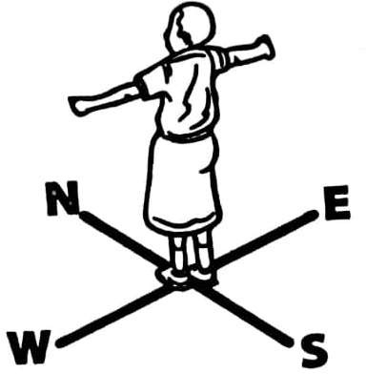

**PRACTICAL ACTIVITY**

* *In the morning, stand under sunshine in your school compound .*
* *Use the position of the sun and your shadow to determine different directions (ie.North, South, West and East)*

**sun**

***Activity***: *Draw the shadow of the girl in the diagram above.*

Note:

* *Shadows of objects are always in the West every morning because the light from the sun in the East is blocked hence forming shadows in the East.*
* *Shadows always appear in the East every evening because the light from the sun in the West is blocked hence forming shadows in the East.*
* *At midday/ noon time, all shadows of objects are around the objects (middle) because the sun overhead.*
* *Shadows are always shortest in the noon time and longest in the evening and morning.*

### Using the position of the sun to tell directions:

#### Example 1:

* James was going to school in the morning and he saw his shadow in front of him. In which direction was his school?

-The school was in the West.

#### Example 2:

* Jane was going to the market in the evening and saw her shadow on the righthand side. In which direction was:

1. Her home?

-In the South

1. The market place?

-In the North.



***Testing Exercise.***

1. Mention the commonest way of telling directions in your community.
2. Name the direction in which the sun appears every morning.
3. Name the direction in which the sun sets.
4. To which direction are shadows of objects always cast every evening?
5. At what time of the day are shadows always the longest?
6. Why are shadows of objects very short at noon?
7. Andrew was going to the hospital at 9:00am and he saw his shadow in front of him. In which direction was the hospital?
8. In which direction do shadows of objects always appear every morning?
9. Draw the shadow of the tree below.

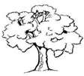

1. Joan was going to the shop in the evening and she saw her shadow on her right hand. In which direction was;
   1. the shop?
   2. her home?

## LOCATING PLACES USING LINES OF LATITUDE AND LINES OF LONGITUDE

 **Grid reference system** is the method of locating places using lines of latitude and lines of longitude.

## LINES OF LATITUDE.

 These are imaginary lines drawn on maps or globe from East to West.

 The general name for all lines of latitude is parallels because they do not meet at any point.

 Latitude is the distance in degrees North or South of the equator.  Lines of latitude help us to determine climate of places.

Major lines of latitude.

* + The Equator (0⁰)
  + Tropic of Cancer (23½⁰N)
  + Tropic of Capricorn (23½⁰S)
    - Arctic circle (66½⁰N)
    - Antarctic circle (66½⁰S)

### The Equator

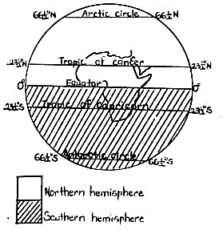

 *The Equator divides the world into two equal parts (hemispheres)*

 *The Equator is marked 0*⁰ *because it is the starting point for all latitude readings.*

 *The Equator is the most important line of latitude because it crosses the world at the centre.*

 *All districts which are crossed by the equator lie in both the Northern and Southern hemisphere.*

*Note:*

 ***A globe*** *is the model of the earth*

 *The Equator crosses lake George and lake Victoria in Uganda.*

 ***A hemisphere*** *is a half part of the world as divided by the equator or prime meridian.*

 *The area between the Tropic of cancer and the Tropic of Capricorn is called the* ***Tropical region****.*

Districts crossed by the Equator in Uganda

* Ibanda
* Kasese
* Mpigi
* Mukono
* Wakiso
* Namayingo
* Mayuge
* Kalungu
* Bukomansimbi
* Buvuma
* Sembabule
* Lyantonde
* Kamwenge

### Location of the Equator on the map of Uganda

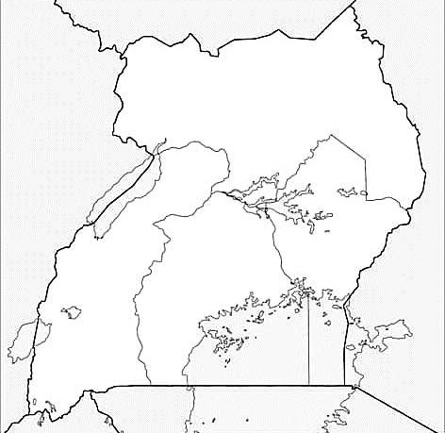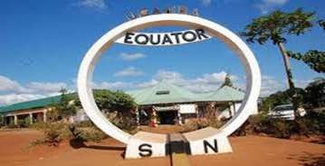

**0**⁰

**Equator**

***Lake George***

**0**⁰

***Location of the Equator at Kayabwe along***

***Kampala-Masaka road***

***Lake Victoria***

#### Practical activity;

*Use the political map of Uganda and identify all districts that;*

1. *Are crossed by the Equator.*
2. *Completely lie in the Northern hemisphere*
3. *Completely lie in the Southern hemisphere.*
4. *Lie in both the Northern and the Southern hemisphere*

## LINES OF LONGITUDE.

 Lines of longitude are imaginary lines drawn on maps and globe from the North pole to the South pole.

 They are also known as meridians.

 Lines of longitude meet at the poles of the earth. Major lines of longitude.

* The Prime meridian/ Greenwich meridian (0⁰)
* The International dateline. (180⁰E or W)

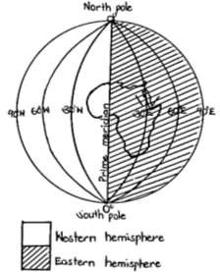

**The Prime meridian/ Greenwich meridian** *The Prime meridian is also called the* ***Greenwich meridian*** *because it crosses Greenwich town in London.*

*The Prime meridian is marked* ***0***⁰ *because it is the starting point for all longitude readings.*

*The Prime meridian divides the world into the Eastern and Western hemisphere.*

*Note;*

* *The* ***Prime meridian*** *helps us to tell the international time.*
* *The* ***International dateline*** *separates one day from another.*

*e.g. East of the International dateline can be Friday while West of it is Thursday.*

Note: *Both lines of latitude and lines of longitude help us to locate places on a map.*



***Testing Exercise.***

1. Give the meaning of Lines of latitude.
2. Name the line of latitude marked 00.
3. Why are lines of latitude sometimes referred to as parallels?
4. Apart from the Equator, name any two other major lines of latitude.
5. What general name is given to lines of latitude?
6. Name any four districts crossed by the Equator in Uganda.
7. Why is the Equator line marked 00?
8. Name the two lakes which are crossed by the Equator in Uganda.
9. Give the meaning of a Hemisphere.
10. Mention the two hemispheres which are formed by the Equator.
11. Give the meaning of Lines of longitude.
12. What general name is given to lines of longitude?
13. Name the line of longitude marked 00.
14. How is the line of longitude in (13) above important?
15. How are lines of longitude and lines of latitude important on a map?

## LOCATION OF OUR DISTRICT IN UGANDA

 A district is an administrative area at the level of Local Council Five (LC V)  Uganda is divided into districts mainly to ease administration.

 Most districts in Uganda have their headquarters in the major towns.

 **Chairperson LC V** is the political head of a district.

 Some districts have municipalities which are divided into divisions.

 Districts in Uganda are divided into counties and sub-counties in order to make administration.

 Districts in Uganda are grouped into regions, and each region is divided into sub- regions according to the customs of the people in that area.

Reasons why Uganda is divided into districts.

* To ease administration.
* To extend social services nearer to people.
* To create more job opportunities. Disadvantages of creating more new districts.
* It leads to separation of communities/ tribes.
* It leads to high administrative costs.
* It makes equal distribution of resources difficult.

## REGIONS THAT FORM UGANDA.

* + Central region
  + Northern region
  + Western region
  + Eastern region

## POLITICAL MAP OF UGANDA SHOWING REGIONS

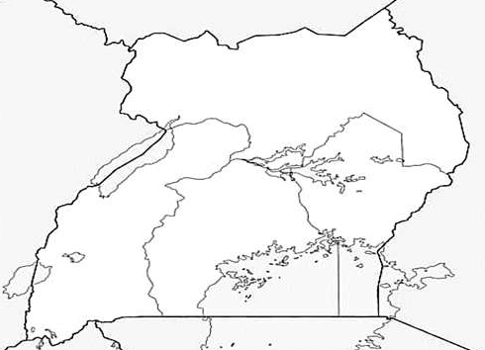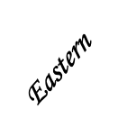

***Northern***

***Practical activity:***

* *Using the political map of Uganda in your Atlas, identify atleast 20 districts located in each region of Uganda shown on the map above.*

***Central***

### Sub-regions found in each region of Uganda.

|  |  |  |  |
| --- | --- | --- | --- |
| ***Region of***  ***Uganda*** | ***Sub-region*** | ***Districts*** | |
| Central region | Buganda sub-region | -Kampala -Mpigi  -Masaka -Mityana  -Luwero -Kalangala  -Nakasongola -Mubende  -Rakai -Wakiso  -Sembabule etc. | |
| Northern region | Acholi sub-region | -Gulu  -Agago | -Kitgum  -Pader |
| Karamoja sub- region | -Kotido -Abim  -Moroto -Kaabong  -Nakapiripirit etc | |
| Lango sub-region | -Lira  -Oyam | -Apac  -Dokolo etc |
| West Nile sub-  region | -Arua  -Yumbe | -Nebbi -Zombo  -Adjumani -Koboko |
| Western region | Bunyoro sub-region | -Hoima  -Masindi | -Buliisa -Kibaale |
| Tooro sub-region | -Kabarole | -Kamwenge -Kyegegwa |
| Rwenzori sub-region | -Kasese | -Bundibugyo -Ntoroko |
| Kigezi sub-region | -Kabale  Rukungiri | -Kisoro -Kanungu - |
| Ankole sub-region | -Mbarara | -Ibanda -Kiruhura |
| Eastern region | Busoga sub-region | -Jinja  -Luuka | -Iganga -Mayuge  -Buyende |
| Teso sub-region | -Soroti | -Serere -Kumi |

|  |  |  |  |  |
| --- | --- | --- | --- | --- |
|  |  | -Amuria etc | | |
| Bugishu sub-region | -Mbale | -Sironko | -Bududa |
|  | -Bulambuli |  |  |
| Sebei sub-region | -Kapchorwa | -Bukwo | -Kween |
| Bukedi sub-region | -Pallisa  -Tororo | -Kibuku  -Busia | -Budaka |

***Testing Exercise.***



* + 1. In which district is your school located?
    2. What title is given to the political head of a district?
    3. Give any three reasons why Uganda is divided into districts.
    4. State any one disadvantages a country may face due to having many districts.
    5. Mention the four geographical regions of Uganda.
    6. In which region of Uganda is your school found?
    7. Apart from your district, name any four other districts that are located in the region in (6) above.
    8. Name the largest geographical region of Uganda.
    9. Mention any three sub-regions found in each of the following regions of Uganda.
       1. Northern region
       2. Eastern region (iii)Western region
    10. Name the town in which the headquarters of your district is found.

## HIGHLAND DISTRICTS

 These are districts which are located in areas of high altitude.  Such districts usually have many hills and mountains.

 Altitude is the height above the sea level. Examples of highland districts.

* Mbale
* Kapchorwa
* Kabale
* Kisoro
* Bundibugyo
* Kasese
* Moroto
* Rukungiri

Economic activities that are commonly carried out in Highland districts.

* Tourism
* Crop growing
* Mining

Problems faced by people living in Highland districts.

* Landslides
* Severe soil erosion
* Poor transport network
* Difficulty in agricultural mechanisation.

Possible solutions to the problems facing people living in Highland districts.

* By rearing donkeys to use them as means of transport.
* By constructing winding roads.
* By practising afforestation and reafforestation to control landslides.
* By terracing, contour ploughing and strip cropping to reduce soil erosion.

### Note:

* *Heavy rainfall is the major cause of landslides in highland areas.*
* *Landslides can be controlled in highland areas by planting more trees.*
* *Ground transport is very poor in highland areas because it is very difficult and expensive to construct roads in highland areas.*
* *Agricultural mechanisation is so poor in highland areas because the steep slopes make the use of tractors difficult.*
* *Road transport can be improved in highland areas by constructing winding roads.*
* *People living in Kapchorwa district rear donkeys mainly to use them as means of transport.*



***Testing Exercise.***

1. Mention any three highland districts in each of these regions of Uganda.
   1. Western region
   2. Eastern region
2. Give the meaning of the term Altitude.
3. Mention any three economic activities that are commonly carried out in highland areas.
4. State any three problems faced by people living in highland areas.
5. Give any two ways the problems in (4) above can be reduced.
6. Give any two ways soil erosion can be controlled in highland districts of Uganda.
7. State the major cause of landslides in highland areas.
8. Give one way road transport can be improved in highland areas.
9. Give one way landslides can be controlled in highland areas.
10. Mention any two ways donkeys are useful to people living in Kapchorwa district.

## ISLAND DISTRICTS.

 An Island is an area of land which is completely surrounded by a water body.  The island districts in Uganda are found in Lake Victoria.

Examples of islands districts.

* Kalangala
* Buvuma

Economic activities that are commonly carried out in Island districts.

* Fishing.
* Crop cultivation (oil palm growing, maize, banana, potatoes)
* Lumbering
* Trading.
* Tourism due to presence of Ssese forest, Ngamba island which is famous for Chimpanzees

Benefits enjoyed by Island districts.

* They get easy access to water.
* They have fertile soils.
* They receive plenty of rainfall.

Problems facing people living in Island districts.

* Poor road transport.
* Attacks from aquatic animals eg.crocodiles.
* Lack of hydro electricity
* Floods
* Poor social service delivery.
* **Note***: -There is no hydroelectricity in Kalangala and because it is very expensive to fix electric poles in water of lake Victoria to these districts.*

Possible solutions to the problems facing Island districts of Uganda.

* By using other sources of energy eg. solar energy
* By employing more social service providers.
* By providing better means of water transport.
* By building better social service centres in island districts.
* By paying attractive salaries to people who provide social services in island districts.



***Testing Exercise.***

* 1. What is an Island?
  2. Name the two island districts in Uganda.
  3. Mention any three economic activities that are commonly carried out in island districts.
  4. State any three problems that are faced by people living in island districts.
  5. Why is Kalangala district referred to as an island district?
  6. Name the major tourist attraction found at Ngamba islands.
  7. Mention any two benefits enjoyed by people living in island districts.
  8. Give any three ways the government can improve the lives of people living in island districts of Uganda.
  9. Mention one factor that hinders industrial production in Kalangala district.
  10. Name the chief cash crop grown in Kalangala district.

## KAMPALA DISTRICT

 **Kampala** is the capital city of Uganda.

 Kampala was originally built on seven hills but its size has been increasing and expanding to more other hills.

 Kampala got its name from the animal called “**Impala**” which were dominant on

the hills that make up Kampala.

 For easy administration, Kampala is divided into urban councils while the rural districts are divided into counties.

 Kampala is headed by the **Lord mayor** while each of the other districts are headed by **Chairperson LC V.**

 Kampala is run by the **Kampala Capital City Authority (KCCA)** which is headed by the **Executive director**.

 The capital city of Uganda was transferred from **Entebbe** to Kampala in 1962 because Kampala had more land for expansion.

 The current Lord mayor is **Erias Lukwago.**

### Divisions that make up Kampala

* Kawempe division
* Central division
* Nakawa division
* Makindye division
* Rubaga division

**A Map of Kampala district.**

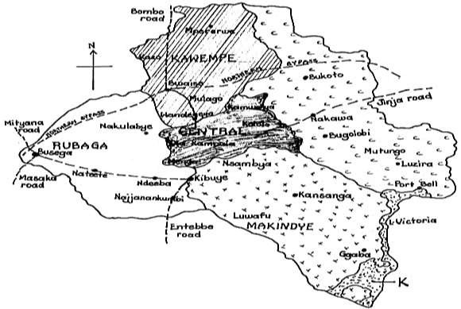

### Reasons why Kampala is divided into divisions

* To ease administration
* To bring social services nearer to people
* To create more job opportunities.

### Neighbours of Kampala district

* Wakiso
* Mukono

#### Note:

* + ***Kampala*** *is the smallest district in Uganda.*
  + ***A municipality*** *is a large town with its own local government.*
  + *A municipality is equivalent to a county in rural areas.*
  + *A municipality is headed by a* ***mayor.***
  + *A municipality is divided into smaller administrative units called* ***divisions.***



***Testing Exercise.***

* + 1. Name the capital city of Uganda.
    2. Write KCCA in full.
    3. What title is given to the political head of Kampala city?
    4. Name the five divisions that form Kampala.
    5. Give any two reasons why Kampala is divided into divisions.
    6. Name the smallest district in Uganda.
    7. What title is given to the political head of a municipality?
    8. Name the two districts that neighbour Kampala district.

## KAMPALA CAPITAL CITY AUTHORITY (KCCA)

 **Kampala Capital City Authority** (**KCCA**) was established by the [Ugandan](https://en.wikipedia.org/wiki/Parliament_of_Uganda) [Parliament.](https://en.wikipedia.org/wiki/Parliament_of_Uganda)

 It was responsible for the operations of the [capital city](https://en.wikipedia.org/wiki/Capital_city) of [Kampala](https://en.wikipedia.org/wiki/Kampala) in [Uganda](https://en.wikipedia.org/wiki/Uganda).  It replaced the **Kampala City Council (KCC)**

 KCCA is headed by the executive director who is appointed by the president.

 **Ms.Dorothy Kisaka** is the current executive director of KCCA. She replaced

**Engineer Andrew Kitaka Mubiru** on 12th June, 2020.

 **Kitaka** replaced **Jennifer Musisi** who resigned on 15th December, 2018.  KCCA has its headquarters on Nakasero hill.

### Roles/ Duties of KCCA.

* It maintains a good road network in the city.
* It promotes sanitation in the city.
* It collects taxes from businessmen and women in the city.
* It maintains order in the city
* It regulates business people in the city.

### Challenges faced by KCCA



* Shortage of funds
* Misunderstandings/conflicts among leaders in the city.
* Poor disposal of wastes
* Corruption among KCCA workers
* Floods in different parts of the city.
* Poor roads.
* High population in the city
* High crime rate in the city.

### Possible solutions to challenges facing KCCA

* By getting soft loans
* By punishing corrupt officials
* By putting more dustbins in the city
* By teaching people the dangers of poor sanitation.
* By improving on security in the city.
* By widening water channels to control floods.

### Achievements of KCCA.

* It has improved sanitation in the city.
* It has built markets in the city.
* It has improved roads in the city.
* It has built schools in the city.
* It has built hospitals in the city.

### Importance of Kampala city.

* It is a trading/ commercial centre.
* It is an administrative centre.
* It is an entertainment centre.
* It is a communication centre.
* It is a source of jobs to many people.

### Important places in Kampala.

* Bank of Uganda
* Parliamentary building
* Churches eg.Namirembe cathedral, Lubaga cathedral
* Mosques eg.Old Kampala mosque, Kibuli mosque.
* Radio stations eg.UBC radio, Beat FM, Radio One etc
* Television stations eg.NTV, NBS TV, Bukedde TV, Dream TV, KTV etc.
* Hospitals eg.Mengo hospital, Mulago hospital, Nsambya hospital etc.
* Schools and universities such as Makerere university, Kyambogo university etc
* Uganda museum at Kitante.
* Military barracks eg.Makindye military barracks, Mbuya military barracks etc.
* High court
* Kololo airstrip.
* State House on Nakasero hill.
* Hotels eg.Sheraton hotel, Serena hotel, Pearl of Africa hotel, Grand Imperial hotel etc.
* Police stations eg.Central Police Station (CPS), Katwe police station etc.
* Bus and taxi parks eg.Old taxi park.
* Embassies and High commissions eg.American embassy, South African High commission etc
* Post office
* Nakivubo stadium
* Market centres eg.St.Balikuddembe market, Usafi market, Kalerwe market etc

### Important places on major hills in Kampala.

|  |  |
| --- | --- |
| ***Hill*** | ***Important places/ features*** |
| Namirembe hill | -Namirembe cathedral |
| Rubaga hill | -Rubaga cathedral -Rubaga hospital |
| Old Kampala hill | -Old Kampala mosque |

|  |  |
| --- | --- |
| Kibuli hill | -Kibuli mosque |
| Nsambya hill | -Nsambya catholic church -St. Peter’s SS Nsambya  -American Embassy -Nsambya hospital |
| Kitante hill | -Uganda museum -British High commission |
| Makerere hill | -Makerere university |
| Nakasero hill | -Grand Imperial hotel -Pearl of Africa hotel  -Kampala Sheraton hotel -Serena hotel -State house  -Parliamentary building -Nakasero market |
| Kololo hill | -Kololo airstrip |
| Mulago hill | -Mulago referral hospital |
| Mengo hill | -Kabaka’s palace -Mengo hospital. |
| Kasubi hill | -Kasubi tombs |
| Muyenga hill | -Water tanks |
| Makindye hill | -Makindye magistrates court -Makindye military barracks |

**Challenges facing Kampala as a capital city**

* Poor sanitation
* High crime rate
* Traffic jam
* Prostitution
* Poor housing
* High levels of unemployment
* High costs of living

### Possible solutions to the problems facing Kampala city.

* By improving on security in the city.
* By constructing wider roads in the city.
* By building storeyed buildings.
* By setting up industries to create more jobs to people
* By constructing houses on plan as set by KCCA
* By encouraging investors into the country.
* By transferring important offices to different districts.

### Newly recognised cities in Uganda.

* 1. Effective 1st July 2020
     + Arua city
     + Gulu city
     + Jinja city
  2. Effective July 1, 2021
     + Hoima City
  3. Effective July 1, 2022
     + Entebbe city
     + Lira City
  4. Effective July 1, 2023
     + Moroto city
     + Nakasongola city
     + Soroti city
     + Mbarara city
     + Fort Portal city
     + Mbale city
       - Kabale city
       - Wakiso City
       - Masaka city

### Why the government is creating more new districts and cities.

* + - * + To make administration easy.
        + To create more jobs.
        + To extend social services nearer to people.



***Testing Exercise.***

Write KCCA in full.

Who is the current executive director of KCCA?

Name the body that governs Kampala city.

State any three roles of KCCA.

What title is given to the head of KCCA?

Mention any three challenges faced by KCCA.

Give any three ways the challenges in (5) above can be solved.

State any three achievements of KCCA.

Give any three ways Kampala city is important.

Mention any four important places found in Kampala district.

State any four challenges facing Kampala as a city.

Give any four ways the challenges in (10) above can be solved.

Mention any four newly recognised cities in Uganda.

Give one reason why the above cities were created.

Match the hills in List A with that given in List B correctly.

***List A List B***

Nakasero hill Water tanks

Kitante hill American embassy

Muyenga hill State house and parliamentary building.

Nsambya hospital Uganda museum and UWA head offices

## THE HISTORY OF OUR DISTRICT.

 **History** is the study of past events.

 Each district in Uganda has its own history.

 The history differs from one district to another.

 In a discussion under the guidance of your teacher, describe the history of your district.

***Important information required.***

* Name of your district.
* Origin of the name of your district.
* Mother district
* Size of your district
* Dominant tribes there.
* Dominant language(s) spoken.
* Economic activities carried out in your district.
* Common crops grown.
* Animals kept there.
* Staple food of people.
* Historical sites in your district.
* Important places in your district.



***Testing Exercise.***

1. In which district is your school located?
2. Give the meaning of the term History.
3. Mention any two districts that neighbour your district.
4. Name any two tribes that are found in your district.
5. Mention any two local languages spoken by people in your district.
6. Mention any three economic activities that are commonly carried out people in your district.
7. Mention any two historical sites found in your district.
8. Name the staple food of the people in your community.
9. Mention nay three common crops grown by people in your district.
10. Mention any four important places found in your district.

## IMPORTANT PLACES IN OUR DISTRICT

* + Schools
  + Courts of law.
  + Radio stations
  + Television stations
  + National parks
  + Taxi parks
  + Factories
  + Hotels
  + Recreation centres
  + Markets
  + Hospitals and health centres
  + Banks
  + Churches
  + Mosques
  + Police stations
  + Ports and landing sites
  + Post office

**Groups of people found at different important p[laces found in our district.**

|  |  |
| --- | --- |
| ***Important place*** | ***Groups of people.*** |
| Schools | -Teachers |
| Hospitals | -Doctors -Nurses -Midwives |
| Banks | -Bankers |
| Mosques | -Imam -Muezzin -Sheikh |
| Hotels | -Hoteliers |
| Television stations | -TV Presenters |
| Radio stations | -Radio Presenters |
| Police posts and police stations | -Police Officers |
| Churches | -Reverends -Pastors -Fathers |

|  |  |
| --- | --- |
| Markets | -Traders |
| Taxi parks | -Drivers |
| National parks | -Game rangers -Game wardens |

## SCHOOLS AND OTHER LEARNING INSTITUTIONS

 **A school** is a place where people go to learn Examples of Primary schools in our district

* + Kampala Parents’ school
  + Greenhill academy
  + Hillside Naalya primary school
  + Buganda Road primary school.
  + Villa Road primary school
  + Sir Apollo Kaggwa primary school
  + Makindye Junior School
  + Victoria Mutundwe primary school

Examples of Secondary schools in our district.

* + Under the guidance of your teacher, identify the different secondary schools found in your district.

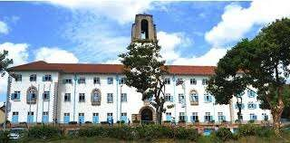

Examples of Universities in our district

* + Makerere University
  + Kyambogo University
  + Ndejje University
  + Kampala International University(KIU)
  + Kampala University
  + Bugema University
  + Islamic University in Uganda (IUIU)

***Makerere university***

* + Uganda Christian University

Examples of Teacher training colleges in our district

* + Shimon Primary Teachers’ College
  + Kabulasoke Core PTC

### People found at school

* + Teachers
  + Cooks
  + Bursar
  + Pupils

Importance of such people at school.

* **Bursar:** He or she collects school fees
* **Teacher:** He or she teaches children
* Busuubizi Core PTC
* Ndegeya Core PTC
  + Matrons
  + Gate keepers
  + Secretary
  + Cleaners
    - **Matron/Warden**: He or She ensures the welfare of the children.
    - **Cooks**: He or she prepares meals at school
    - **Watchmen**: He or she ensures security at school.

### Problems faced by some schools in Uganda.

* Shortage of land for expansion.
* Shortage of textbooks.
* Shortage of well trained teachers.
* Shortage of funds.
* Shortage of enough classrooms.
* Shortage of furniture.
* Too many pupils in the classrooms.
* Mismanagement of funds by school administrators.

### Solutions to the problems facing schools.

* By training more teachers.
* By acquiring loans from banks for smooth running of schools.
* The government should provide enough furniture to schools.
* The government should provide more textbooks to schools.
* By constructing more classroom blocks.

### Importance of a school to the nearby community.

* It is a source of employment to people.
* It creates market to goods from the community.
* It promotes development in an area
* It provides education service to children.

### Importance of the community to the school.

* It provides labour to the school.
* It provides food to the school.
* It provides security to the school.
* It gives learners to the school.

### Causes of misunderstanding between the school and the nearby community

* Noise from the school.
* Stealing of school property.
* Use of abusive language by the pupils.
* Trespassing.
* Littering of wastes to the neighbourhood.



***Testing Exercise.***

1. Name the biggest government university in Uganda.
2. What roles are performed by the following groups people in your school?
   1. Teachers
   2. Watchmen
3. State any three problems facing schools in Uganda today.
4. How is a school signpost important to people in the community?
5. Mention any two symbols on which a school going child can be identified.
6. Give any three ways the above challenges can be solved.
7. Mention any two groups of people who care for pupils at school.
8. Give any three ways a school benefits people in the nearby community.
9. State any two ways a school benefits from people in the community.
10. Mention any two causes of misunderstandings between the school and the neighbourhood.

## MEDICAL CENTRES/ HEALTH CENTRES

 **A Medical centre** is a place where people get health service.

 Medical centres include; hospitals, health centres, dispensaries, clinics etc

 **An Ambulance** is a vehicle that transports casualties to hospitals.

### Major hospitals in Uganda.

* Mengo hospital
* Butabika national referral hospital
* St.Francis hospital Nsambya.
* Rubaga hospital
* Kiruddu hospital.
* [Arua Regional Referral Hospital](https://en.wikipedia.org/wiki/Arua_Regional_Referral_Hospital)
* [Fort Portal Regional Referral](https://en.wikipedia.org/wiki/Fort_Portal_Regional_Referral_Hospital) [Hospital](https://en.wikipedia.org/wiki/Fort_Portal_Regional_Referral_Hospital)
* [Gulu Regional Referral Hospital](https://en.wikipedia.org/wiki/Gulu_Regional_Referral_Hospital)
* [Hoima Regional Referral Hospital](https://en.wikipedia.org/wiki/Hoima_Regional_Referral_Hospital)
* [Jinja Regional Referral Hospital](https://en.wikipedia.org/wiki/Jinja_Regional_Referral_Hospital)
* [Kabale Regional Referral Hospital](https://en.wikipedia.org/wiki/Kabale_Regional_Referral_Hospital)
* [Lira Regional Referral Hospital](https://en.wikipedia.org/wiki/Lira_Regional_Referral_Hospital)
* [Masaka Regional Referral Hospital](https://en.wikipedia.org/wiki/Masaka_Regional_Referral_Hospital)
* [Mbale Regional Referral Hospital](https://en.wikipedia.org/wiki/Mbale_Regional_Referral_Hospital)
* [Mbarara Regional Referral Hospital](https://en.wikipedia.org/wiki/Mbarara_Regional_Referral_Hospital)
* [Moroto Regional Referral Hospital](https://en.wikipedia.org/wiki/Moroto_Regional_Referral_Hospital)
* [Mubende Regional Referral Hospital](https://en.wikipedia.org/wiki/Mubende_Regional_Referral_Hospital)
  + Mulago hospital (largest national referral hospital in Uganda.)

*Note:*

* + - ***Mengo hospital*** *was the first hospital to be built in Uganda.*
    - *It was built by a Christian missionary called* ***Dr.Albert Cook*** *in 1897.*

|  |  |
| --- | --- |
|  |  |
| *Mengo hospital* | *Butabika hospital* |

### Groups of people who provide health service.

* Doctors
* Nurses
* Midwives
* Health assistants
* Herbalists

### Groups of doctors and their work.

* **Dentist**- examines and treats people sick teeth.
* **Optician**- examines and recommends eye glasses.
* **Oculist**- examines and treats sick eyes.
* **Surgeon**- operates sick people.
* **Psychiatric**- treats sick brains.
* **Gynaecologists**- study and treat sexual reproductive diseases in women.

**Note:*Midwives****- help pregnant women to give birth.*

*- also provides antenatal and postnatal services to women.*

### Services provided by health centres.

* + Treatment
  + Blood testing
  + Guidance and counselling
  + First aid
  + Maternal care

### Importance of a hospital in the community

* It is a source of employment to people.
* It provides people with treatment.
* It provides market for goods produced in the community.
* It provides guidance and counselling services to people.



***Testing Exercise.***

* 1. Mention any three places where health service is provided.
  2. Name any three major hospitals found in your district.
  3. Mention any three groups of people who provide health service.
  4. Name the largest referral hospital in Uganda.
  5. How are midwives important to people in your community?
  6. Name the first hospital to be built in Uganda.
  7. Mention any three services provided by health centres.
  8. How are the following groups of people important in the hospital?
     1. Dentists
     2. Surgeons
     3. Oculists
  9. Why is Dr. Albert Cook remembered in the development of the health sector in Uganda?
  10. Give any three ways a hospital is important to people in your community.

## MARKETS.

 **A market** is a place where people buy and sell goods.

 Goods sold in a market include; sugar, beans, fruit, shoes, clothes, electric appliances, utensils etc.

Other places where goods are sold.

* Shops
* Supermarkets

Groups of people work in the market.

* Market vendors
* Porters
* Hawkers

Examples of markets in Kampala district.

* St.Balikuddembe market (formerly Owino market)
* Nakasero market.
* Wandegeya market
* Kikuubo shopping zone
* Mpanga market in Fort Portal
* Gulu main market
* Shopkeepers
* Peddlers
* Herbalists.
* Bugolobi market
* Jinja Central market
* Mbale main market
* Usafi market
* Nakawa market
* Kasubi market
* Kalerwe market

|  |  |
| --- | --- |
|  |  |
| *Jinja central market* | *Hoima central market* |

### Importance of markets in the community.

* + They are source of employment to people
  + They are source of basic needs.
  + They are source of taxes to the government.
  + They are a source of income to people who work there.



***Testing Exercise.***

* + 1. Apart from markets, mention any four other important places in your district.
    2. Mention any four trade items sold in markets.
    3. Name any three groups of people who work in market places.
    4. Mention any two basic needs of man obtained from markets.
    5. Apart from markets, mention any one other place where people buy and sell goods in your community.
    6. Name any four major markets found in your district.
    7. Give any three ways markets are important to people in your community.
    8. Mention any two groups of people who bring goods nearer to people in your community.
    9. Mention any four major markets located in Kampala district.
    10. How are porters important in market places?

## PLACES OF WORSHIP

* + Churches • Shrines • Mosques

|  |  |  |
| --- | --- | --- |
|  |  |  |
| *Namirembe cathedral* | *Namugongo shrine* | *Old Kampala mosque* |

Examples of religious leaders.

* + Priests
  + Cardinals
  + Bishops
  + Sheikh
  + Pastors
  + Reverends
  + Imam
  + Muezzin

Importance of religious leaders.

* + They preach the word of God /Allah.
  + They officiate religious functions.
  + They settle disputes among people.. Importance of places of worship.
* They are worshipping centres.
* They are a source of jobs to people.
* They promote peace in the community
* They promote unity among believers.
  + They are used as centres to officiate religious marriages



***Testing Exercise.***

* + 1. Apart from churches and mosques, mention any four other important places in your district.
    2. Mention any two places where people worship God in your community.
    3. Give any three ways religious leaders are important in the community.
    4. Mention any two examples of Christian religious leaders.
    5. Mention any two examples of leaders found in the mosque.
    6. Give one way churches and mosques are important to people in your community.
    7. State any one way religious leaders help to promote peace among people in your community today

## BANKS

Types of banks

* + Commercial banks
  + Central bank

### Central bank

 It is also called Bank of Uganda.  It is headed by a **governor.**

 The current governor of the Bank of Uganda is **Mr.Tumusiime Mutebire**. **Duties of the Central Bank**

* To print new currency
* To control the amount of money in circulation
* To control commercial banks in the country
* To keep government’s money and money from other banks
* To manage government’s debts
* To lend money to other banks
* To give license to new banks

### Importance of the Central bank to Commercial banks

* It gives licenses to the commercial banks
* It gives loans to the commercial banks

1. **Commercial banks**
   * DFCU bank
   * Eco Bank
   * Standard Chartered bank
   * Stanbic bank
   * Bank of Uganda
   * Diamond Trust Bank

### Importance of Commercial banks

* + They keep people’s money safely
  + Cairo International bank
  + Centenary bank
  + Equity bank
  + Opportunity bank
  + Housing Finance bank
  + They keep people’s important documents like land titles
  + They give loans to people for development
  + They give advice to business people.
  + They create job opportunities to people.



***Testing Exercise.***

* + 1. Apart from banks, mention any four other important places in your district.
    2. Mention any two types of banks in your community.
    3. Write BOU in full.
    4. What title is given to the head of the central bank in Uganda?
    5. What name is given to the central bank in Uganda?
    6. Give any two ways the central bank is important to a country.
    7. Mention any three commercial banks operating in your district.
    8. Give one way commercial banks benefit from the central bank.
    9. State any three ways commercial banks are useful to people in your community.
    10. Give one reason why people are encouraged to keep their money in banks.

## POST OFFICE

 **A post office** is a place where letters and parcels are sent and received from.

 Every institution should have a box number in order to be able to send and receive letters and parcels.

 The largest post office in Uganda is in **Kampala city**

**P.O** is the short form of **Post Office**. Services provided by the Post Office

* + Communication services
  + Banking service through Post Bank
  + Transport service through Post bus Means of communication at the Post Office
  + Letters
  + Telephones

Importance of the Post Office

* It sells stamps.
* It offers banking service.
* It offers transport service.
* It helps to send people’s letters
  + Telegram
  + Telefax
* It helps to send parcels of people
* It creates job opportunities to people.



***Testing Exercise.***

1. Apart from post offices, mention any four other important places in your district.
2. In which district is the largest post office in Uganda found?
3. Write down the post office box number of your school.
4. Mention any two social services provided by the post office.
5. Name any two means of communication that are commonly used at a post office.
6. Give any three ways a post office is important to people in your community.

## THE POLICE POSTS AND POLICE STATIONS

 **A Police station** is a place where the police carries out the activity of maintaining law and order.

 The Uganda Police force is in charge of maintaining law and order.  It is under the **Ministry of Internal affairs**

 The top commander of the Uganda Police is called **Inspector General of Police (IGP)**

 The head of police force is the **District Police Commander (DPC)**. Examples of police stations in our district.

* + Central Police Station (the largest in Uganda)
  + Kira road police station

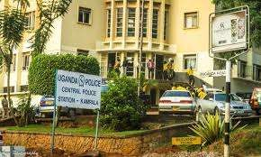

*Central Police Station in Kampala*

* + Nateete police station
  + Katwe police station
  + Nabweru police station
  + Kasangati police station etc.

### Tools/ things used by the police officers.

* + Guns
  + Tear gas
  + Shield
  + Baton

### Roles or duties of the Uganda Police

* To enforce law and order
* To investigate crimes

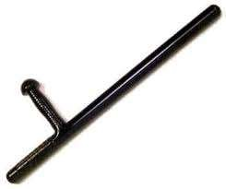

*a baton*

* To arrest wrong doers
* To stop riots.
* To protect human life and property.
* To control the flow of vehicles on roads.

### How the Police enforces law and order

* By arresting suspected law breakers.
* By investigating crimes.
* By escorting very important people.
* By controlling the flow of traffic.



***Testing Exercise.***

1. Apart from police stations, mention any four other important places in your district.
2. Mention any two police stations found in your district.
3. What title is given to the head of the police force in the district?
4. Write IGP in full.
5. State the main duty of the police.
6. Name the largest police station in Uganda.
7. Under which ministry is the Uganda police?
8. Mention any two tools used by the police officers to maintain law and order.
9. Give any three ways the police force is important to people in your district.
10. Mention any two ways police officers maintain law and order in your community.

## PRISONS

 **A prison** is a place where law breakers are kept and encouraged to reform. Examples of major prisons in Uganda.

* + Luzira prison (the largest in Uganda)
  + Kampiringisa prison
  + Kigo prison

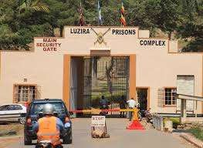

* + Nalufenya prison
  + Nakasongola prison
  + Masindi prison Importance of prisons.
* They keep law breakers in safe custody.
* They train prisoners practical skills such as brick making, carpentry etc.

*Luzira prison*

* They reform prisoners.

## COURTS

 These are places where disputes among people are settled. Examples of cases settled in courts of law.

* + Murder
  + Rape
  + Defilement
  + Theft
  + Corruption etc.

Groups of people who are taken to courts of law for trial

* Murderers
* Rapists
* Bad drivers

Groups of people who work in courts of law.

* + Judges
  + Magistrates
  + Lawyers
  + Registrars

Importance of courts of law.

* They settle disputes among people.
* They interpret laws to people.
* They promote unity among people.
* They teach people about the laws.
* Corrupt officials
* Thieves
  + They are a source of employment to people.
  + They are a source of income to the government eg. court fines got from the law breakers.



***Testing Exercise.***

* + 1. Apart from prisons and courts of law, mention any four other important places in your district.
    2. What name is given to a place where law breakers in your community are kept?
    3. Name the largest prison in Uganda.
    4. Give any two ways prisons are important in your community.
    5. Mention any two major prisons found in your district.
    6. Why are law breakers kept in prisons?
    7. Mention any three criminal cases that are commonly settled in courts of law.
    8. Mention any three groups of people that are commonly taken to courts of law for trial.
    9. Write down any three groups of people who work in courts of law.
    10. Give any three ways courts of law are important in your community.

## RADIO STATIONS AND TELEVISION STATIONS.

 **A Radio station** is a place where radio programmes are broadcast. Examples of Radio and Television stations.

* + UBC FM
  + Radio West
  + CBS radio
  + Radio One
  + Capital FM
  + Impact FM
  + K FM
  + Kingdom radio
  + Radio Simba
  + Super FM

Examples of Television stations.

* + UBC TV
  + Urban TV
  + Bukedde TV
  + HG TV
  + BBS TV
  + Star TV
  + NTV
  + NBS TV
  + LTV

|  |  |
| --- | --- |
|  |  |
| ***Masengere building****, the home of*  *BBS TV and CBS radio* | ***Serena hotel****, the home of NTV* |



Importance of radio and television stations.

* + They provide news to people.
  + They entertain people.
  + They provide jobs to people.

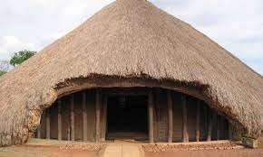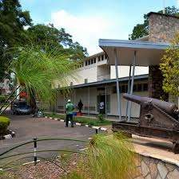

* + They pay taxes to the government.
  + They advertise goods and services.



***Testing Exercise.***

* + 1. Apart from radio and television stations, mention any four other important places in your district.
    2. What name is given to a place from where radio programmes are broadcast?
    3. Mention any two radio stations found in your district.
    4. Name any one radio stations that broadcasts in the local language spoken by people in your district.
    5. Give any two ways radio stations are important to people in your community.
    6. Mention any four television stations in Uganda.
    7. State any two ways television stations are important to people in your district.

## HISTORICAL SITES

 **Historical sites** are places where events of long ago took place. Examples of historical sites include;

* + Stone age sites eg.Bigobyamugenyi, Magosi, Nyero, Paraa, Luzira etc
  + Cultural sites eg. Kasubi tombs, Bulange palace,
  + Museums eg.Uganda museum at Kitante hill in Kampala

|  |  |
| --- | --- |
|  |  |
| *Kasubi tombs* | *Uganda museum located at Kitante* |

* **Stone age sites** are places where early man lived.
* **A museum** is a building where things of long ago and art crafts are kept and displayed.
* **Cultural sites** are places where culture is preserved.
* **Culture** is the way of life of people in a given society. Importance of historical sites.
  + They attract tourists who bring in income.
  + They provide job opportunities to people.
  + They help in preservation of culture.



***Testing Exercise.***

* + 1. Apart from historical sites, mention any four other important places in your district.
    2. What are stone age sites?
    3. Mention any three stone age sites in Uganda.
    4. What name is given to a place where things of long age and art crafts are kept and displayed?
    5. Give the meaning of the term Culture.
    6. Mention any one cultural site located in Kampala district.
    7. Name the largest museum in Uganda.
    8. Give any two ways historical sites are important to people in your district.

## NATIONAL PARKS.

 **A national park** is a large area gazetted by the government to protect wildlife.

 **Wildlife** are animals, birds, plants and insects that live on their own.

 The **Uganda Wildlife Authority (UWA)** is responsible for conservation of wildlife in Uganda.

 **Murchison falls national park** is the largest game park in Uganda.

 **Uganda Wildlife Education Centre (UWEC)** -formerly Entebbe zoo is a place where selected wildlife species are conserved on small scale for the public to see.

Examples of National parks in Uganda.

* Murchison falls national park
* Queen Elizabeth national park
* Lake Mburo national park
* Kidepo valley national park
* Mgahinga national park
* Mountain Elgon national park
* Mountain Rwenzori national park
* Bwindi national park

Activities that commonly take place in Uganda’s national parks.

* Animal tracking
* Mountain climbing
* Game drives
* Boat rides.

Prohibited/ illegal/ unauthorised activities in national parks.

* Animal grazing
* Crop cultivation
* Hunting
* Human settlement

**Location of major National parks and Game reserves in Uganda.**

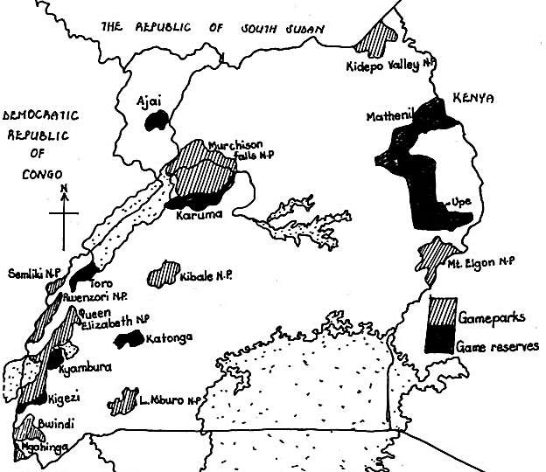

Examples of animals and birds in Uganda’s national parks.

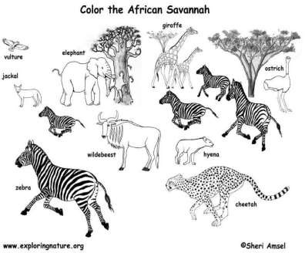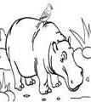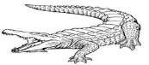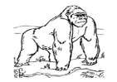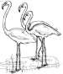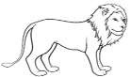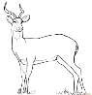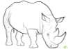

**Flamingo birds**

**Mountain gorilla**

**Crocodile**

**Hippopotamus**

**acacia**

**Leopard**

**kob**

**Crested crane**

**warthog**

**rhino**

**Common wildlife species in Savannah grasslands**

**lion**

Importance of national parks.

* They create job opportunities to people e.g. The game rangers, game wardens.
* They earn income through attracting tourists.
* They promote the development of hotels and roads.
* They are used for education and scientific research.
* They help to preserve wildlife for future use.
* They promote international relationships.

Problems facing game parks in Uganda.

* Poaching
* Wild bush fires
* Drought
* Outbreak of diseases
* Political instability in some areas.
* Outbreak of animal diseases.

Possible solutions to problems facing national parks.

* By enforcing laws against poaching.
* By teaching people about the importance of wildlife.
* By improving on security in areas near national parks.
* By extending veterinary services in national parks.
* By building valley dams to provide water to animals.
* By enforcing laws against human settlement in national parks.



***Testing Exercise.***

* 1. What is a National park?
  2. Name the largest national park in Uganda.
  3. Apart from the above national park, mention any three other national parks found in Uganda.
  4. Write the following in full.
     1. UWA
     2. UWEC
  5. Name the body that is responsible for conservation of wildlife in Uganda.
  6. Mention any four animal species commonly found in Uganda’s game parks.
  7. Mention any three species of birds that are common in Uganda’s game parks.
  8. Give any four ways national parks are important to a country.
  9. Mention any two activities that are commonly carried out in Uganda’s game parks.
  10. Mention any two activities that are not allowed in game parks.
  11. State any three problems facing game parks in Uganda.
  12. Give any three ways the problems in (11) above can be solved.

## LEISURE CENTRES.

 These are places where people go to rest/ relax. Examples of Leisure centres in our district.

* + Hotels
  + Stadia
  + Theatres
  + Beaches
  + Bars
  + Amusement parks
  + Disco halls

|  |  |
| --- | --- |
|  |  |
| *Mandela national stadium* | *Club Ambiance* |



|  |  |  |
| --- | --- | --- |
| ***Leisure centre*** | ***Examples*** | ***Importance*** |
| Hotels | -Serena hotel  -Pearl of Africa hotel  -Grand Imperial hotel  -Hotel Africana  -Sheraton hotel | * They provide accommodation to people * They create job opportunities to people. * They are used for meetings. * They help people to relax. |
| Beaches | -Gaba beach  -Lido beach  -Nabugabo beach  -KK beach  -Munyonyo Resort beach. | * They are used for entertainment. * They help people to relax. |
| Stadia | -Mandela national stadium  -Nakivubo stadium  -St.Mary’s Stadium  -Masaka Recreation grounds  -Bugembe stadium | * They are used for sports eg.football, athletics, rugby * They are used for conferences. * They create jobs to people. * They are used for entertainment. |



***Testing Exercise.***

* + 1. Apart from leisure centres, mention any four other important places in your district.
    2. Name any two major hotels found in your district.
    3. Give any two ways hotels are important to people in your district.
    4. Mention any three examples of stadia found in your district.
    5. Mention any three sports activities carried out in stadia.
    6. Give one way games and sports are important to school children.
    7. Give any two ways stadia are important in your community.
    8. Name the largest stadium in Uganda.
    9. Give one reason why school children are given holidays.
    10. State any one reason why people go to beaches during their leisure time.

## FACTORIES

 **A factory** is a place from where goods are manufactured.

 Factories use raw materials to manufacture goods/ products. Examples of factories in our district

* + Riham factory
  + Mukwano
  + Nice House of plastics
  + Uganda Baati
  + Roofings
  + Hima cement factory
  + Nile Breweries
  + Tororo cement factory
  + Bidco
  + Maganjo grain millers

Examples of goods/ products made from factories.

|  |  |
| --- | --- |
| *Raw material* | *Products/ goods made* |
| Cotton | Clothes -cotton wool |
| Palm oil | Soap -cooking oil -margarine |
| Limestone | Cement |
| Phosphates | Artificial fertilizers |
| Copper | Electric wires -copper coins |
| Pyrethrum | Insecticides |
| Maize | Maize flour |
| Tobacco | Cigarettes |

Importance of factories/ industries to people.

* They are a source of employment to people.
* They attract tourists who bring in income.
* They pay taxes to the government.
* They provide goods to people in the community.

Importance of people to factories.

* People provide labour in factories.
* They provide market for goods produced by factories.
* They provide raw materials to factories. Problems faced by people living near factories.
* Factories pollute the environment
* Much noise from the factories.



***Testing Exercise.***

* 1. Apart from factories, mention any four other important places in your district.
  2. Mention any four examples of factories found in your community.
  3. Mention any four processed goods obtained from industries/ factories found in yopur community.
  4. Name the raw material used for making cement.
  5. Mention any two products obtained from copper.
  6. How is the growing of pyrethrum useful to farmers?
  7. Name the mineral which is used for making artificial fertilizers.
  8. Give any two ways factories are important to people in your community.
  9. State any one problem facing people who live near industries in your community.
  10. Give any two ways people benefit industries found in their locality.

## AGRICULTURAL RESEARCH CENTRES

 These are places where research on crops and animals is done. eg. Kawanda research centre in Wakiso district.

 Agriculture is the growing of crops and rearing of animals. Examples of Agricultural research organisations.

* **NAADS**- National Agricultural Advisory Services.
* **NARO**- National Agricultural Research Organisation. Importance of Agricultural Research centres
* Agricultural centres provide improved seeds to people
* They provide jobs to people.
* They train agricultural officers.
* They teach farmers on how to improve their crops and animals.

## PETROL STATIONS

 **A Petrol station** is a place where petroleum products are sold.

 **A Garage** is the place where vehicles are taken for repair/ service.

 **A Mechanic** is a person who repairs vehicles. Examples of petroleum products.

* + Petrol
  + Diesel
  + Aviation fuel.
  + Paraffin/kerosene
  + Gas ▪ Oil.

Examples of Petrol stations in Uganda.

* Shell



* Gulf
* Total
* Pearl
* Africa
* Hass
* Moil
* Delta
* Petrocity
* Kobil
* Gapco

Importance of petrol stations in our community.

* + They are a source of job opportunities to people.
  + They are a source of fuel eg. paraffin, diesel etc.
  + They are a source of income to the government.

### Other important places in our district

* Airports eg. Entebbe international airport in Wakiso.
* Airstrips eg. Kololo airstrip.
* Airfields eg.Soroti airfield, Arua airfield, Kasese airfield etc.
* Railway stations
* Bus parks and taxi parks
* Forest reserves eg. Mabira forest, Budongo forest, Bugoma forest, Kibale forest
* Ports eg. Port Bell, Port Jinja, Port Bukakata, Port Butiaba etc.
* Administrative centres eg. District headquarters, Sub-county headquarters etc.

### Ways of caring for important places in our district.

* By keeping them clean.
* By painting schools, hospitals, banks etc.
* By reporting strangers found in such places.
* By planting trees around important places.
* By respecting people who care for the important places.
* By teaching people on proper use of important places.
* By showing love for important places.
* By fencing important places in our community.



***Testing Exercise.***

* 1. Apart from agricultural research centres, mention any four other important places in your district.
  2. Give ant two ways agricultural research centres are important to people in your community.
  3. Write NAADS in full.
  4. State any one way farmers can be helped to increase crop yields on their farms.
  5. Name the international airport of Uganda.
  6. In which district is the international airport of Uganda found?
  7. Mention any two examples of airfields in Uganda.
  8. Mention any three major inland ports in Uganda.
  9. Name the town in which the headquarters of your district is found.
  10. Give any four ways one can care for the important places in his/ her community.
  11. Mention any three petroleum products sold at a petrol station.
  12. Name the mineral that is used for making petroleum products.
  13. Mention any three examples of petrol stations in your district.
  14. Give any two ways petrol stations are important to people in your community.
  15. Why is it not advisable for people to settle near petrol stations?

TOPIC 2:

PHYSICAL FEATURES IN OUR DISTRICT.

## INTRODUCTION TO PHYSICAL FEATURES

 Physical features are landforms of the earth that give it shape. Types of physical features

* + - Drainage features
    - Relief features

### Relief features:

 These are landforms that are identified according to their altitude.  Relief is the physical appearance of an area

 Altitude is the height of land above the sea level Examples of relief features

* Mountains
* Valleys
* Hills

### Drainage features:

* Rift valley
* Plateaus
* Plains

 These are landforms that contain water.

 Drainage is the ground water system of an area. Examples of drainage features.

* Oceans
* Lakes
* Seas
* Rivers
* Streams



***Testing Exercise.***

1. Give the meaning of each of the term Physical features.
2. Mention the two types of physical features.
3. Mention any two examples of drainage features.
4. Give the meaning of the term Relief.
5. Mention any two examples of relief physical features.
6. Which physical feature **covers** the largest part of your district.

## MOUNTAINS AND HILLS IN OUR DISTRICT.

 A Hill is a piece of land higher than the area around.

 A Mountain is a high large piece of land usually higher than a hill.  Many mountains in an area form a range.

 A peak is the highest point of a mountain.



***a peak***

A map symbol of a **mountain peak**

**a mountain**

Examples of mountains in Uganda.

* + Mountain Rwenzori.
  + Mountain Zulia.
  + Mountain Elgon.
  + Mountain Morungole.
  + Mountain Mufumbiro.
  + Mountain Napak.
  + Mountain Kadam.
  + Mountain Moroto.

Highest peaks of major mountains in Uganda,.

|  |  |
| --- | --- |
| *Mountain* | *Highest peak* |
| Mountain Rwenzori | Margherita |
| Mopuntain Elgon | Wagagai |
| Mountain Mufumbiro | Muhavura |
| Mountain Moroto | Sokdek |

Economic activities commonly carried out on the slopes of mountains and hills

* + - Crop growing
    - Lumbering
      * Tourism
      * Mining

**Major mountains in Uganda.**

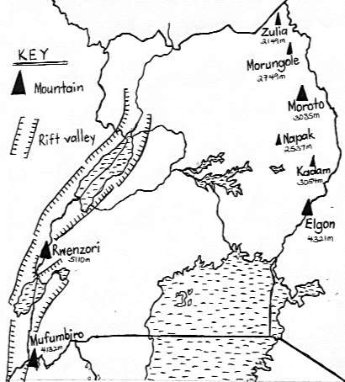

### Importance of hills and mountains

* They help in rain formation ie.Relief rainfall.
* They have fertile soils which support crop cultivation.
* They attract tourists who bring in income.
* They have cool temperatures which favour dairy farming.
* They are used by telecommunication companies to place on masts.
* Some mountains are a source of rivers.
* Some mountains are a source of minerals eg.Osukuru hills in Tororo which provide limestone.
* They provide building materials eg.stones
* Some mountains form natural boundaries between places/ districts.

eg-Mountain Rwenzori creates a natural boundary between Uganda and DRC.

-Mountain Elgon creates a natural boundary between Uganda and Kenya.

-Mountain Mufumbiro creates a natural boundary between Uganda and Rwanda.

**A diagram showing the formation of Relief (Orographic rainfall)**

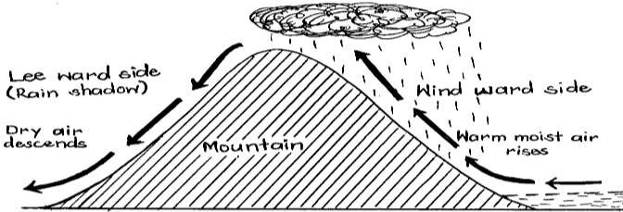

**Note:**

* + *The wind ward side of a mountain receives plenty of rainfall because it receives moist winds.*
  + *The lee ward side of a mountain receives very little rainfall because it receives dry winds.*
  + *The wind ward side is suitable for crop growing because it receives plenty of rainfall.*

### Disadvantages of mountains.

* They hinder agricultural mechanisation.
* They make road and railway construction difficult.
* Some mountains erupt and destroy property.
* They have steep slopes which promote soil erosion.
* They are greatly affected by landslides. and soil erosion.

### Problems faced by people living on slopes of mountains.

* Severe soil erosion.
* Landslides eg.in Bududa district.
* Volcanic eruptions.
* Poor road network.
* Much coldness.
* Poor agricultural mechanisation.
* Attacks from wild animals.

### Possible solutions to the problems faced by people living in mountainous areas.

* By rearing donkeys for transport
* By terracing the land to reduce soil erosion.
* By planting trees to control landslides.
* By contour ploughing to reduce soil erosion.
* By resettling people to safe plains.
* By constructing winding roads.

### How to control soil erosion in highland areas.

* By terracing.
* By contour ploughing.
* By strip cropping



***Testing Exercise.***

1. Mention any four major mountains in Uganda.
2. Draw the map symbol of a mountain peak in the space provided below.
3. Name the highest mountain in Uganda.
4. Mention any three economic activities that are commonly carried out in highland areas.
5. Give any four ways mountains are important to people.
6. Which type of rainfall is mostly received in highland areas?
7. How are hills useful to telecommunication companies?
8. How are mountains useful to the construction industry?
9. Name the mountain that lies along the border of Uganda and Kenya.
10. State any two economic importance of mountains.
11. Why does the lee ward side of a mountain usually receive very little rainfall?
12. Which factor favours crop growing on the wind ward side of the mountain?
13. Mention any two ways soil erosion can be controlled in highland areas.
14. Give any three dangers of hills and mountains in an area.
15. Mention any three problems faced by people living in highland areas.
16. State any three ways people living in highland areas can solve the problems they face.
17. What causes landslides in highland areas?
18. Give one way landslides can be controlled in highland areas.
19. Which animal is commonly used for transport in highland areas?
20. How can road transport be made possible in hilly areas?

## VALLEYS AND RIFT VALLEY

 A valley is a low land between two close hills.

 A rift valley is a long wide depression on the earth’s surface with steep sides.



***A valley***

***A map symbol of a rift valley***

**hill**

**hill**

Economic activities commonly carried out in valleys/ rift valleys.

* + Crop growing
  + Fishing
  + Mining
  + Tourism

Problems faced by people living in valleys/ rift valley areas.

* Poor transport and communication
* Floods.
* High temperatures.

### Importance of rift valleys

* They are source of income through tourism
* It promotes wild life conservation
* They form natural boundaries between places
* They are a source of lakes and rivers
* They provide land for crop growing.



***Testing Exercise.***

1. What is a Valley?
2. What name is given to the steep sides of a rift valley?
3. State any two problems faced by people living in valleys.
4. Mention any two economic activities that are commonly carried out in valleys.
5. What term refers to a low land between highlands?
6. Draw a map symbol of the rift valley in the space provided below.
7. Give two ways valleys are useful to people in your community.

## PLATEAUX AND PLAINS

 A plateau is a raised flat topped piece of land.  A plain is a large flat area.

 The plateau covers the largest part of Uganda.

Features found on a plateau

* + Lakes
  + Rivers
* Streams
* Valleys
  + Hills

Economic activities carried out in plateau areas.

* + Crop cultivation
  + Tourism
  + Fishing

Importance of plateaus.

* + Mining
  + Animal rearing
  + Lumbering.
  + Industrialisation.
* They have fertile soils for crop growing.
* They are used for building industries.
* They are used for human settlement.
* They promote wildlife conservation.
* They have plenty of pasture for animal rearing.
* They promote tourism.
* The help in formation of cyclonic rainfall.

### Formation of Cyclonic rainfall.

 Cyclonic rainfall is formed when cold dry winds meet the warm moist winds.  The stronger wind (cold dry wind) pushes the weaker one (warm moist winds)

forcing it to rise and condense forming clouds

 This rainfall is always very light in form of drizzles and lasts for a short period of time.

 The meeting point of the two winds is called a front

### A diagram showing the formation of Cyclonic / Frontal rainfall

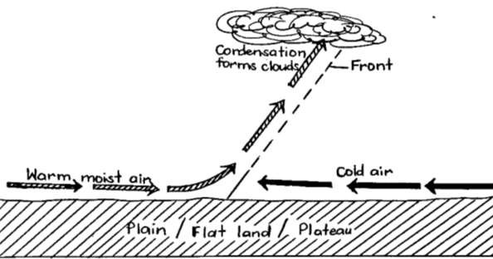

***Testing Exercise***

1. What is a Plateau?
2. Which physical feature covers the largest part of your district?
3. Mention any three economic activities commonly carried out on a plateau.
4. Mention any two physical features that are found on a plateau in your district.
5. Which type of rainfall is mostly received in plains?
6. What name is given to the meeting point of the warm moist winds and dry winds during the formation of the above type of rainfall?
7. Give any three ways a plateau is useful to people in your locality.

## LAKES IN OUR DISTRICT

 A lake is a mass of non-flowing water on the earth’s surface.  Or: A lake is a large area of water that is surrounded by land. Examples of major lakes in Uganda.

* + Lake Victoria.
  + Lake Albert.
  + Lake Mburo.
  + Lake Bunyonyi.
  + Lake Katwe.
  + Lake Kyoga.
  + Lake Edward. Types of lakes.
    - Permanent lakes.
    - Seasonal lakes.
  + Lake George.
  + Lake Wamala.
  + Lake Kwania
  + Lake Nakivali
  + Lake Bisina
  + Lake Kijanebalola
  + Lake Opeta.

Permanent lakes are lakes which contain water throughout the year. Examples of permanent lakes in Uganda.

* + Lake Victoria.
  + Lake Mburo.
  + Lake Albert.
  + Lake Edward.
  + Lake George.
  + Lake Kyoga

**Seasonal lakes** are lakes which dry up in the dry season and get water in the wet season.

|  |  |
| --- | --- |
|  |  |
| *A map symbol of a* ***permanent lake*** | *A map symbol of a* ***seasonal lake*** |

Location of major lakes and rivers on the map of Uganda.

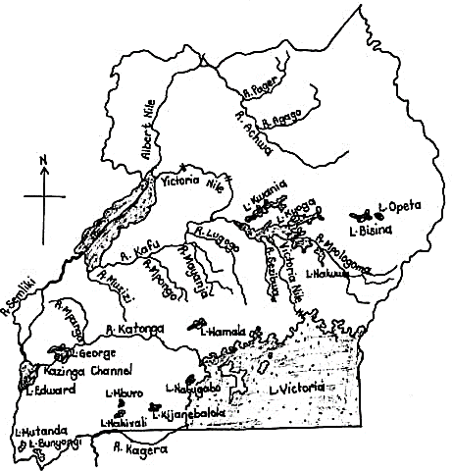

Importance of lakes and rivers

* + They help in rain formation.
  + They act as fishing grounds.
  + They attract tourists who bring in income.
  + They are homes for some animals. eg.fish, crocodiles.
  + They form natural boundaries between places.
  + They provide water for irrigation, domestic and industrial use.

### Formation of Convectional rainfall

 Convectional rainfall is formed as a result of evaporation, transpiration, condensation and precipitation

 High temperatures over water bodies cause evaporation.

 When sun rays heat the plants such as trees then it causes transpiration

 The water vapour from water bodies and plants go to the atmosphere and condense to form clouds

 Due to heaviness, the clouds break and fall on earth as rain.

**Note:**

* *The sun rays heat water in water bodies causing evaporation.*
* *Convectional rainfall is mostly received around large water bodies and forested areas.*

A diagram showing the formation of Convectional rainfall.

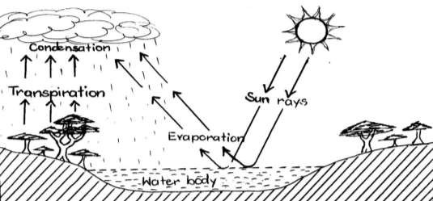

Processes involved in the formation of convectional rainfall

* Evaporation
* Condensation
* Transpiration

Economic activities carried out near lakes.

* Fishing
* Crop growing
* Tourism
* Transportation
* Mining

Resources/ important things obtained from lakes.

* Sand
* Fish
* Water Dangers of lakes.
  + Drowning
  + They cause flooding
  + They harbour dangerous aquatic animals.

Problems facing lakes and rivers

* + - Salt
    - Soda ash
* They harbour disease vectors.
* Lakes hinder road and railway construction.
  + Silting. This reduces the depth of water bodies.
  + Overuse of water from lakes for irrigation.
  + Drought which lowers the water level.
  + Dumping of wastes into water bodies.
  + Over fishing

Caring for lakes.

* By using proper fishing methods.
* By planting trees around lakes.
* By treating industrial wastes before dumping them in lakes.
* By teaching people about the importance of lakes.

Reasons why lake shores and river banks are densely populated.

* They have fertile soils for crop growing.
* They receive reliable rainfall.
* They have a lot of employment/job opportunities.



***Testing Exercise***

1. Name the largest lake in Uganda.
2. Mention the two types of lakes.
3. Draw a map symbol of a seasonal lake in the space below.
4. Give any three ways lakes are useful to people.
5. Mention any two processes that are involved in the formation of convectional rainfall.
6. Which type of rainfall is mostly received around large water bodies?
7. How do lakes help to modify climate of an area?
8. Mention any three economic activities that are commonly carried out on water bodies.
9. Give one way lakes are politically important.
10. Which lake in Uganda is known for salt mining?
11. How is the sun useful in the rain cycle?
12. Give any two ways lakes are dangerous in the environment.
13. Give one reason why very many people usually settle on the slopes of mountains.
14. State any one way lakes can be cared for.
15. Mention any two problems facing lakes and rivers.

## RIVERS IN OUR DISTRICT.

 *A river* is a mass of flowing water on the earth’s surface.

 Rivers flow from areas of high altitude to areas of low altitude.

 Rivers continuously get their water from rainfall, melting snow from high mountains or underground springs.

 Some rivers originate from highlands because such areas receive plenty of water which is a source of water to rivers.

Examples of major rivers in Uganda .

* River Nile
* River Kafu
* River Mayanja
* River Kagera
* River Mpologoma
* River Achwa
* River Katonga
* River Sezibwa
* River Nkusi

### Types of rivers

* River Semliki
* River Manafwa
* River Mubuku

 **Permanent rivers**.These are rivers which flow throughout the year. Examples of permanent rivers.

* River Nile
* River Kafu
* River Kagera
* River Mpologoma
* River Achwa
* River Katonga
* River Sezibwa

 **Seasonal rivers**.These are rivers that mainly flow during the wet season and dry up during the dry season.

### Map symbols related to rivers

|  |  |  |  |
| --- | --- | --- | --- |
|  |  |  |  |
| *permanent river* | *seasonal river* | *a waterfall* | *a dam* |

**Stages of River development**

 A river has three main stages/ courses. These are;

* + The Youth stage/Upper course
  + The Mature stage/ Middle stage
  + The Old stage/ Lower stage (Senile)

### A diagram showing a river system.

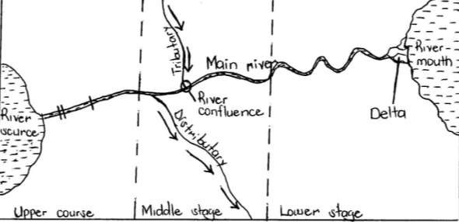

**Terms related to rivers.**

* + - A river source is a point where a river begins to flow.
    - A river mouth is a point where a river ends its flow.
    - A tributary is a small river that joins the main river.
    - A distributary is a small river that branches away from the main river.
    - A river confluence is a place where two or more rivers meet.
    - An estuary is a wide part of a river as it ends its flow.
    - A delta is the place where a river forms several streams as it ends its flow eg.The Nile delta.

***Note:***

* *Deltas have rich fertile soil for crop growing.*
* *They also attract tourists who bring in income.*
* ***A waterfall*** *is a steep flow of a river.*

***Or.****It is a point where a river flows from high altitude to a low altitude.*

* ***A Cataract*** *is a series of waterfalls on a river.*
* *Waterfalls attract tourists who bring in income, and also help in generation of hydro electricity.*
* *However, waterfalls may cause water accidents and also block water transport.*

*Examples of waterfalls in Uganda.*

* + *Karuma falls*
  + *Itanda falls*

### Importance of rivers.

* They are a source of fish.
* *Sipi falls*
* *Murchison falls*
  + *Sezibwa falls.*
* They help in the formation of convectional rainfall.
* They are source of income through tourism.
* They provide water for domestic use.
* Rivers help in the generation of Hydro Electric Power/ hydroelectricity.
* They act as recreation centres. Problems caused by rivers in an area.
* Drowning
* Flooding
* Rivers are breeding places for disease vectors.
* They hinder road construction.
* They harbour dangerous animals.

### Major economic activities carried out on and around rivers.

#### Carried out on rivers Carried out around rivers.

-Fishing -Crop farming

-Transportation -Tourism

-Mining

-Tourism



***Testing Exercise***

1. Name the longest river in Uganda.
2. Apart from the above river, mention any four other major rivers in Uganda.
3. Draw the map symbols of the following.

|  |  |
| --- | --- |
| A waterfall | A permanent river |
|  |  |

1. Give the meaning of each of the following;
   1. A tributary
   2. A river confluence
2. Mention any three major waterfalls in Uganda.
3. Give any two ways waterfalls are economically important to a country.
4. Mention the three stages of river development.
5. Give any four ways rivers are important to people in your community.
6. State any three problems caused by rivers in an area.
7. Which type of electricity is generated from fast flowing water?

### General importance of physical features.

* Lakes and rivers are a source of fish.
* They help in the formation of rain.
* They are source of income through tourism.
* Lakes and rivers provide water for domestic use.
* Rivers help in the generation of Hydro Electric Power/ hydroelectricity.
* They act as recreation centres.
* Mountain slopes and lake shores have fertile soils which support crop cultivation.
* Hills and mountains are used by telecommunication companies to place on masts.
* Some mountains are a source of rivers.
* Some physical features are a source of minerals eg.Osukuru hills in Tororo which provide limestone.
* Mountains provide building materials eg.stones
* Lakes and rivers provide water for irrigation.
* They form natural boundaries between places/ districts.

### Dangers of physical features

* Some of them are hiding for wrong doers
* They harbour dangerous wild animals
* They are bleeding places for disease vectors
* Lakes and rivers flood which kills people.
* They hinder road construction.
* Mountains hinder agricultural mechanisation.
* Some mountains erupt and destroy property.
* Hills and mountains have steep slopes which promote soil erosion.
* Mountains are greatly affected by landslides. and soil erosion.

### Ways of caring for the physical features

* BY Planting trees on shores of lakes and mountain slopes and river banks
* BY discouraging people from dumping rubbish in water bodies
* By terracing land to control soil erosion in highlands.
* By sensitising people about the importance of different physical features.
* By using proper fishing methods.
* By filling holes after mining.
* By treating wastes before disposing them in water bodies.



***Testing Exercise***

1. Write HEP in full.
2. How do lakes and rivers help to modify climate of an area?
3. Name the major mineral mined from Osukuru hills in Tororo.
4. Mention any one building material obtained from mountains.
5. Give one way physical features are politically important in the environment.
6. Give any three ways lakes and rivers are economically important.
7. State any two problems faced by people living near lakes and rivers.
8. Mention any two problems faced by people living in mountainous areas.
9. State any two ways lakes and rivers can be cared for.
10. Give one way mountains hinder economic development in an area.